HW Practice: Constant of Proportionality and Proportional Relationships

Find the constant rate of change for each ordered pair then determine if the table shows a proportional relationship.
Time | Temperature  (°F)
9:00 | 60
10:00 | 62
11:00 | 64
12:00 | 66

Time Spent  Mowing (h) | Money Earned  ($)
1 | 10
3 | 30
5 | 50
7 | 70

1. 2.

Number of  Trees | Number of  Apples
5 | 100
10 | 200
15 | 300
20 | 400

Number of  Students | Number of  Magazines Sold
10 | 120
15 | 170
20 | 220
25 | 270

3. 4.

5. 6.
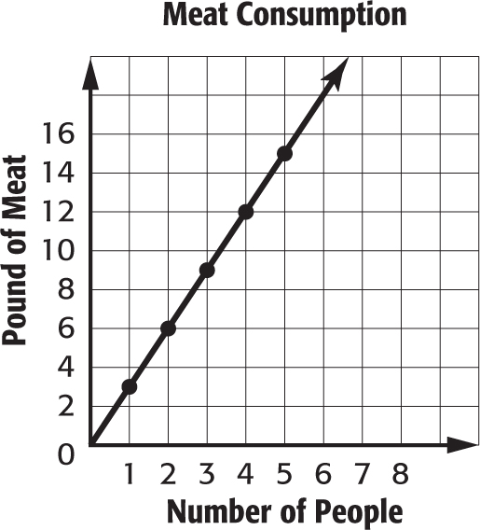
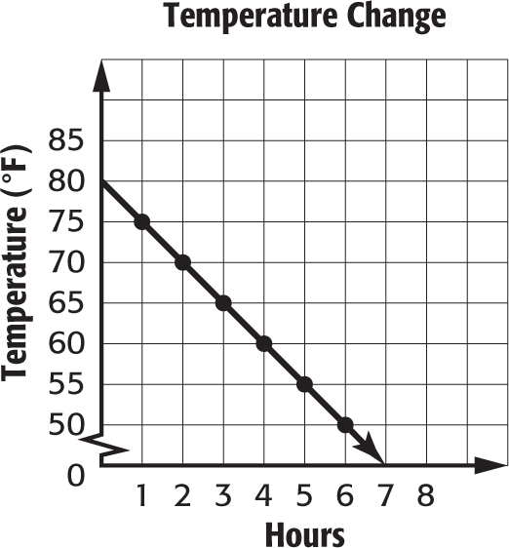

Number of  Hours Worked | Money  Earned ($)
4 | 80
6 | 120
8 | 160
10 | 200

Number of  Pounds of Ham | Cost ($)
0 | 0
3 | 12
6 | 24
9 | 36

7. 8.

Months | Money Spent on Cable TV
2 | 82
4 | 164
6 | 246
8 | 328

9. 10.
Days | Plant Height (in.)
7 | 4
14 | 11
21 | 18
28 | 25

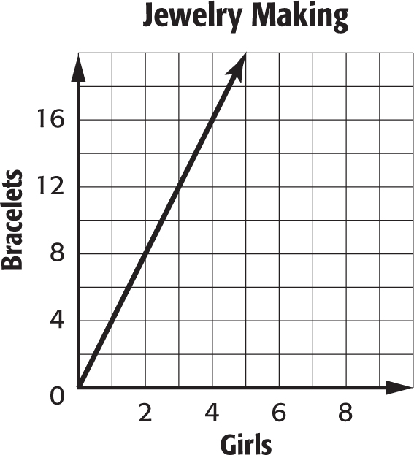
11. 12.
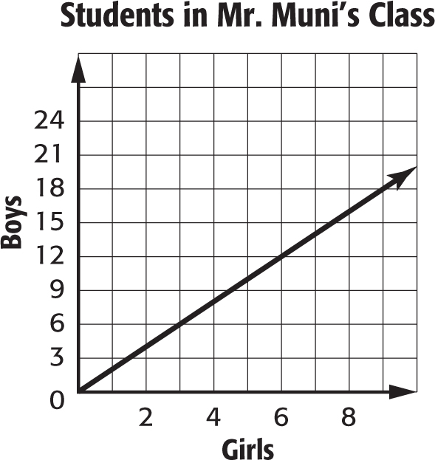

13. SEAGULLS When Joy went to the beach, she saw no seagulls. Two hours later, at 11 am, there were 16 seagulls on the beach. At 2 p.m., there were 40 seagulls. Is the relationship proportional?

