Math 7/8 Name ___________________________________
Unit 6: Geometric Applications of Exponents Class _______________
Review

- Explain the parts of the Pythagorean Theorem formula.

- How are the formulas for volume of a cylinder and volume of a cone similar? How are the they different?

Proficiency of Skills
2in.
4in.
- Find the length of the missing side. Round to the nearest hundredth.

- Find the length of the missing side. Round to the nearest hundredth. (Hint: The two dashes on the bottom means those two lengths are congruent.)
8 cm
10 cm
10 cm
x cm
12 in.
- Solve:

- Solve:

- Determine the volume of the sphere. Write your answer in terms of π.
8 cm
10 cm

- Determine the volume of the cone. Round your answer to the nearest hundredth.

- The volume of a cylinder is 90π cubic inches. If the height of the cylinder is 10 inches, what is its diameter?

- A cylinder has a volume of 301.44 cubic centimeters. Find the volume of a cone with the same height and diameter as the cylinder.

- A cube has a volume of 27 cubic inches. What is the volume of the largest sphere that will fit in the cube? Round to the nearest hundredth of an inch.
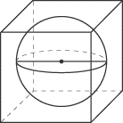

- The vertices of 3 squares are joined to form a right triangle. What is the area of the largest square?
22 cm²
14 cm²

- The screen on a computer monitor has a length of 40 inches and a width of 22 inches. What is the length of the diagonal to the nearest hundredth of an inch.

- Determine the length of line segment AB. Round your answer to the nearest hundredth of a unit.
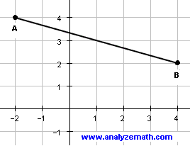
- Find the volume of a cylinder whose diameter is 14mm and height of 12mm. Round your answer to nearest hundredth.

- How do we know if three lengths form a right triangle? _______________________________________________ _____________________________________________________________________________________________

- A baseball diamond is pictured below. A ball is thrown from 1st base to home and then from home to 2nd base. How far did the ball travel in all??

90 ft
90 ft
90 ft
90 ft
3rd base
1st base
2nd base
Home Plate

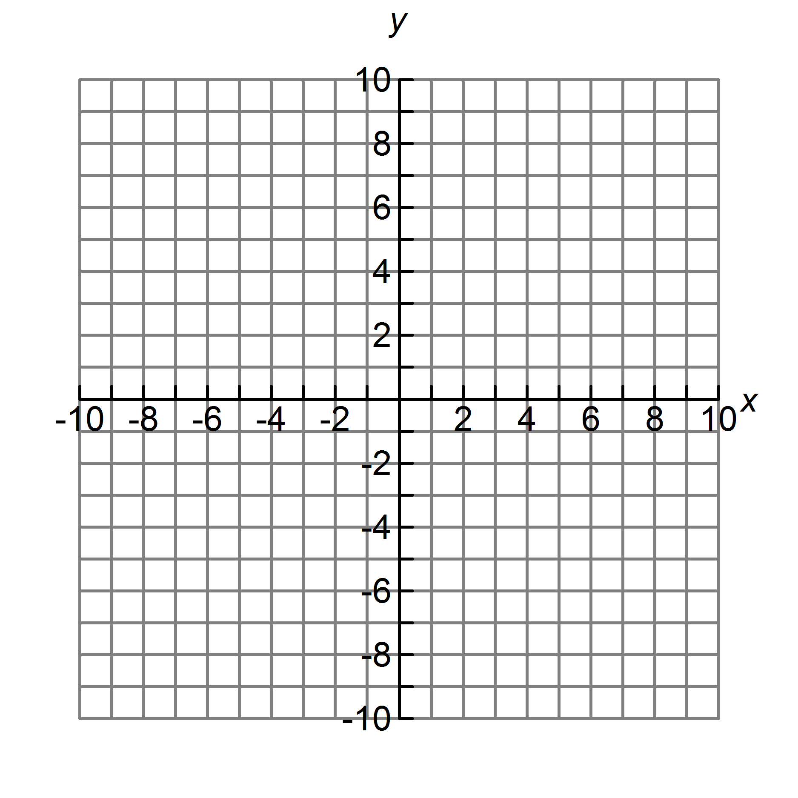
- What is the distance between the point (-4, 2) and the origin?

19 . What is the length of the space diagonal (red line) if the dimensions of the box are as given?
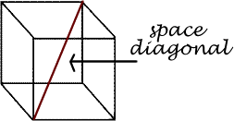

5in
3in
4in

- We are having a party at my house. The glasses that I bought are in the shape of a cylinder. They are 8 inches high and have a 2 inch radius. I bought some really cool ice that is in the shape of a sphere. The radius of the ice sphere is 1 inch. If I put 10 ice spheres in my glass, how much diet Coke can I add? (round to the nearest hundredth)

