Box and Whisker Plots Name_______________________________
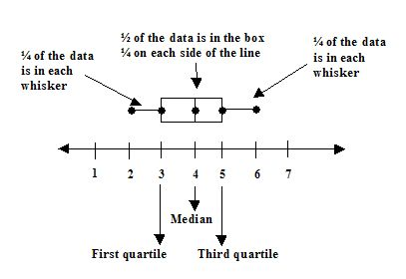
Minimum (lower extreme):

Measures of variation - these measures show how spread out or close together the data in a set are, or how much the data points vary.

Measures of central tendency - describe the center of a data set.

1st Quartile:

Median:

3rd Quartile:

Maximum (upper extreme):

Steps to making the Box and Whisker Plot:
14, 8, 22, 16, 19, 9, 25, 12, 5, 11, 10

1) order the values from smallest to largest

2) find the median – put a box around it

3) Q1 (lower quartile) - find the median of the first half of the numbers – circle it

Q3 (upper quartile) - find the median of the second half of the numbers – circle it

4) Find the extremes – lower and upper – underline both

Interquartile range (IQR) – difference between the third quartile and the first quartile.

Use the data to create a box-and-whisker plot:

69, 61, 74, 78, 72, 68, 70, 60

Below are the quiz scores from students in two different class sections. Which section has greater variability in the scores?

Section 1: 7, 9, 9, 10, 8, 6, 8, 5, 5, 9, 10, 7, 8, 7, 9
Section 2: 7, 8, 9, 9, 8, 8, 7, 9, 9, 10, 8, 8, 7, 10, 8

Create a box-and-whisker plot for both of the class sections.
Compare the range and interquartile range for each section.

Section 1 Section 2

Range: Range:

IQR: IQR:

