Name__________________
Date____________________
Class____________________
HW – Quiz Unit 5
- Define: complementary, supplementary, vertical and adjacent angles. Draw an example of each:
____________________________________________________________________________________________________________________________________________________________________________________________________________________________________________________

- Two angles are supplementary and one angle measures 127 degrees. What is the measurement of the other angle?_________________.

- Two angles are complementary and angle (A)’s measurement is X + 5 and the other angle (B)’s measurement is 2x +4. What do each of the angles measure? (hint: Add the 2 angles together and set equal to 90) solve for X, then substitute in for X and find each angle).

- Two angles are supplementary. ANGLE A measures 3x+10;
ANGLE B measures 4x+9.

What are the measurements of ANGLE A and ANGLE B?
(hint: Add the 2 angles together and set equal to 180) solve for X, then substitute in for X and find each angle).

USE THE DIAGRAM BELOW FOR QUESTIONS 5-9.
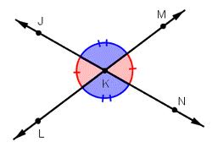
- Name the 4 angles shown above: ___________; ___________
___________; __________

- Name 2 angles adjacent to angle LKN _____________.

- Name an angle that is supplementary to angle MKN._______________.

- Name 2 pairs of vertical angles ______ & ______ _____ & _____.

- Name an angle supplementary to angle JKL __________.

