Name: _________________________________________ Date: _________________ Period: _________
Unit 4 ~ Geometry
Triangles Sides and Angles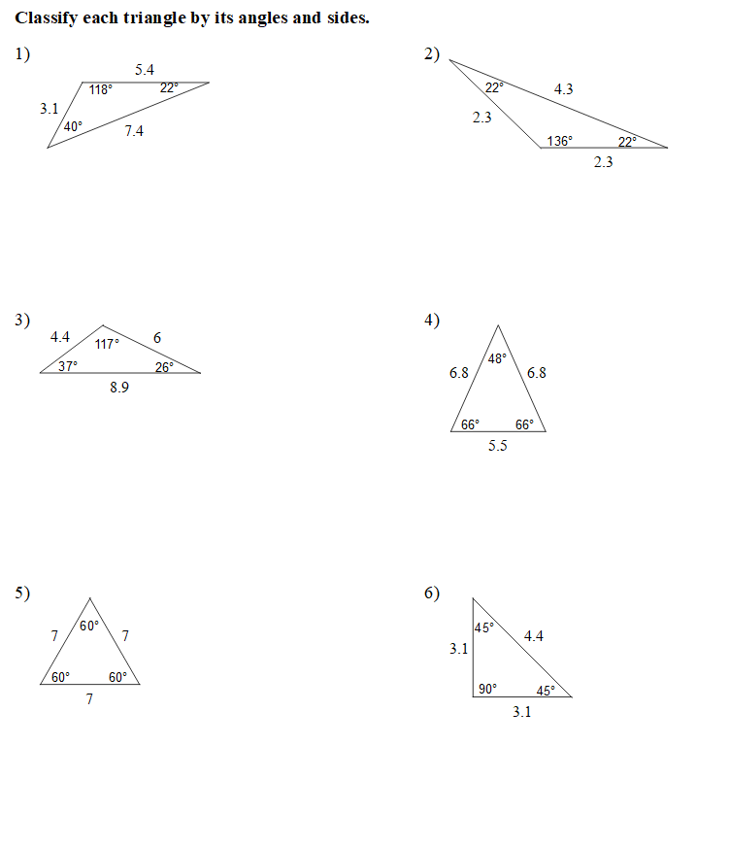

Determine whether the line segments can form a triangle (Yes or No). If the measures do form a triangle, classify the triangle based on its sides.
7. 18m, 12m, 8m __________________________ 8. 24in, 15in, 4in _______________________
9. 10yds, 8yds, 8yds _______________________ 10. 3.7in, 8in, 5.9in _____________________
11. 15mm, 8mm, 4mm ______________________ 12. 11.2ft, 1.7ft, 1.7ft ___________________

Determine whether the given measures form a triangle (Yes or No). If the measures do form a triangle, classify the triangle based on is angles.
13. 60°, 30°, 90° __________________________ 14. 41°, 67°, 72° _______________________
15. 54°, 36°, 100° _________________________ 16. 113°, 42°, 35° _____________________
17. 81°, 62°, 37° __________________________ 18. 39°, 52°, 90° _______________________

Use what you know from the Learning Task about the side lengths of a triangle to calculate the shortest and longest possible third leg.

- If the If two sides of a triangle have lengths 12 cm and 9 cm, the third side must be
greater than _____________ and less than _______________.
If the 3rd is the shortest If the 3rd is the longest leg

- If two sides of a triangle have lengths 8 cm and 15 cm, the third side must be
greater than _____________ and less than _______________.
If the 3rd is the shortest If the 3rd is the longest leg

