**Unit 4: Geometry** Name: _______________________________   
**Mid-Unit REVIEW : Angles, Triangles and Circles** Date: ___________ Period: _______

1. Explain how to calculate the circumference of a circle?

____________________________________________________________________________________________________________________________________________________________

2. Solve for the given variable. 3. Solve for the given variable.

5m 3y + 11   
 10°  
 40° 15°   
   
   
   
   
  
 ___________ ___________

Directions: Use the figure to solve problems 4 and 5.

4. Solve for x. 5. What is the measurement of Q?

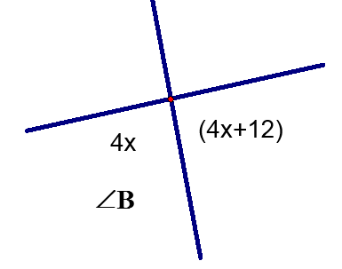

5h

5h - 13

Q

___________ ___________

Directions: Given the lengths below, can these form triangles?

6. 10 cm, 7 cm, 6 cm __________ Work:

7. 5 cm, 12 cm, 5 cm __________ Work:

Directions: Given the measurements below find the missing angle in the triangle, then classify the triangle by its angles and its sides.

Angle Measure Classify the Triangle

38º and 52º 8. __________ 9. ________________ _________________

48º and 66º 10. __________ 11. ________________ _________________

12. In the triangle shown, the measure of  is 29 degrees, the measure of is 116 degrees, and the measure of is 40 degrees.

(HINT: Label all the angle measures as you find them.)



What is the measure of**?** ___________

1. Find the area of the triangle below. **Area =** _______________

17 in



9 in

16 in

1. Find the area of the given figure (round to the nearest whole number): **Area =**________________

Work:

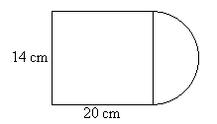

10 ft

13 ft

|  |  |  |  |  |  |  |  |
| --- | --- | --- | --- | --- | --- | --- | --- |
|  |  |  |  |  |  |  |  |

15. Calculate the circumference of the circle. 16. Calculate the area of the circle.

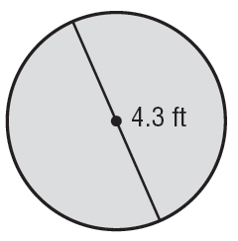

14 in

7 in

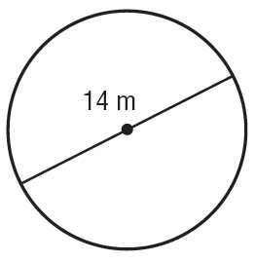

C=________________ A=_____________________

Directions: Name the parts of a circle based on the labeled on the circle

17. _______________________

18. _______________________

19. _______________________

20. Distance around the circle

_______________________

17.

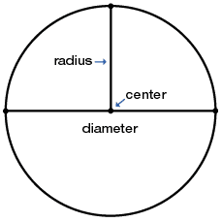

19.

18.

20.